MAZDA RX-8 170KW 231PK RENESIS HP
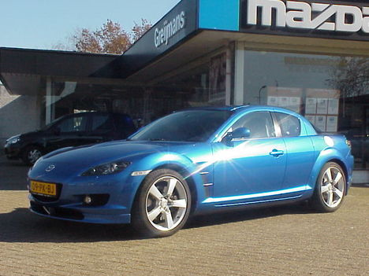
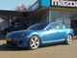 | 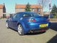 | 